

December 1, 2016

SUBJECT: 2017 Annual Denominational Renewal Conference Requirement and Invitation

TO: All CBAmerica Endorsed Military Chaplains

1. This is to remind you of our annual training requirements for all military chaplains serving under CBAmerica (CBAA)

2. You are required to attend at least one Regional Ecclesiastical Conferences to remain in good standing for endorsement unless prevented by Active Duty mission requirements.

3. To facilitate your opportunity for attendance, eight (8) Regional Events are currently scheduled across the US. See the attached spreadsheet with dates, times, locations, and other information needed to schedule your attendance and participation. Be sure to plan travel time to and from current duty station and the conference site. Some events include activities for couple and family activities.

4. Thank you for making the time and effort to take advantage of this opportunity for personal and spiritual renewal, contact with denominational leadership and constituency members, as well as ongoing professional development. Be sure to advise your local command to request TDY travel support as authorized and available.

5. If you have questions or concerns, please feel free to contact me by phone at 303- 263-6175 or by email at chapandy@cbamerica.org.

.

Looking forward to the seeing you at a conference!

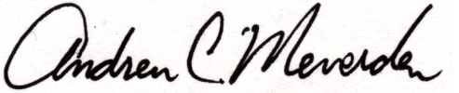

Rev. Andrew C. Meverden, M.Div, M.S.

Chaplain, Colonel, USA, Retired

Director of Chaplaincy, Endorser  
 CBAmerica  
 3686 Stagecoach Rd, Unit F.  
 Longmont, CO 80504-5660  
 Cell: 303-263-6175